**STORED PROCEDURE**

**SCENARIO 1:**

CREATE TABLE Accounts (

    AccountID NUMBER PRIMARY KEY,

    Customer_ID NUMBER,

    AccountType VARCHAR2(20),

    Balance NUMBER,

    LastModified DATE

);

**OUTPUT:**

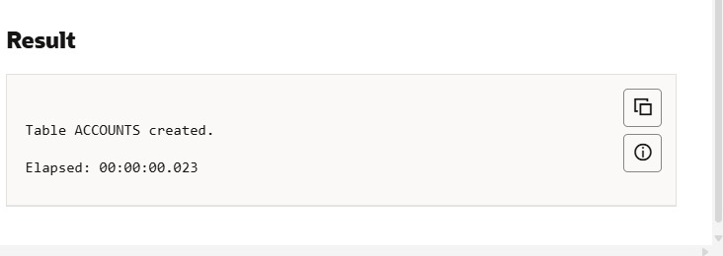

SELECT object_name, object_type

FROM user_objects

WHERE object_name = 'ACCOUNTS';

CREATE OR REPLACE PROCEDURE ProcessMonthlyInterest IS

BEGIN

    UPDATE Accounts

    SET Balance = Balance + (Balance * 0.01)

    WHERE UPPER(AccountType) = 'SAVINGS';

DBMS_OUTPUT.PUT_LINE('Monthly interest applied to savings accounts.');

END;

/

BEGIN

    ProcessMonthlyInterest;

END;

/

**OUTPUT:**

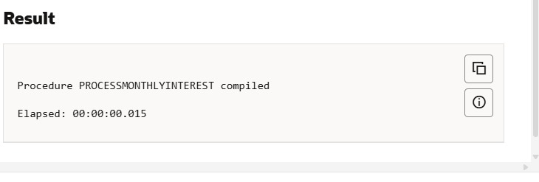

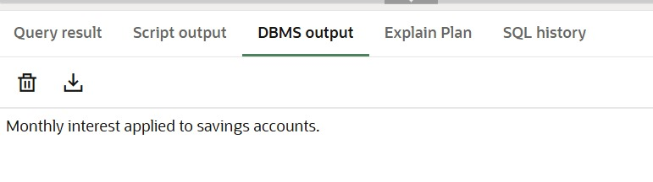

INSERT INTO Accounts (AccountID, Customer_ID, AccountType, Balance, LastModified)

VALUES (101, 1, 'SAVINGS', 15000, SYSDATE);

INSERT INTO Accounts (AccountID, Customer_ID, AccountType, Balance, LastModified)

VALUES (102, 2, 'SAVINGS', 23000, SYSDATE);

INSERT INTO Accounts (AccountID, Customer_ID, AccountType, Balance, LastModified)

VALUES (103, 3, 'SAVINGS', 1000, SYSDATE);

COMMIT;

BEGIN

    ProcessMonthlyInterest;

END;

/

SELECT * FROM Accounts;

**OUTPUT:**

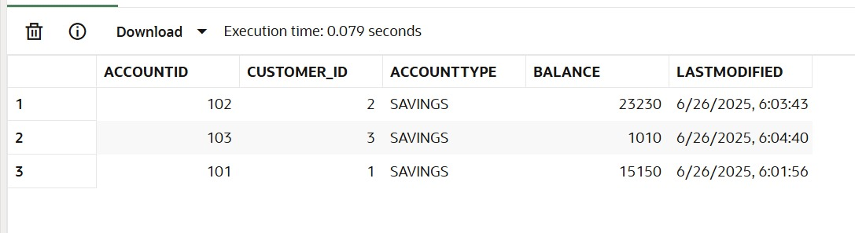

**SCENARIO 2:**

CREATE TABLE Employees (

    EmployeeID NUMBER PRIMARY KEY,

    Name VARCHAR2(100),

    Position VARCHAR2(50),

    Salary NUMBER,

    Department VARCHAR2(50),

    HireDate DATE

);

**OUTPUT:**

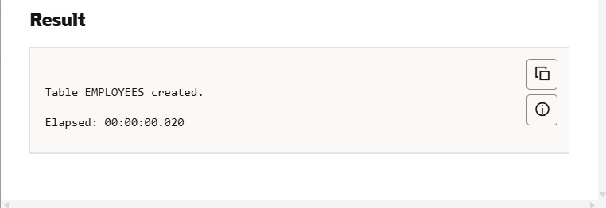

INSERT INTO Employees VALUES (1, 'Alice Johnson', 'Manager', 70000, 'HR', TO_DATE('2015-06-15', 'YYYY-MM-DD'));

INSERT INTO Employees VALUES (2, 'Bob Brown', 'Developer', 60000, 'IT', TO_DATE('2017-03-20', 'YYYY-MM-DD'));

INSERT INTO Employees VALUES (3, 'Charlie Ray', 'Tester', 50000, 'IT', TO_DATE('2019-08-01', 'YYYY-MM-DD'));

CREATE OR REPLACE PROCEDURE UpdateEmployeeBonus(

    p_department IN VARCHAR2,

    p_bonus_percent IN NUMBER

)

AS

BEGIN

    UPDATE Employees

    SET Salary = Salary + (Salary * p_bonus_percent / 100)

    WHERE Department = p_department;

    DBMS_OUTPUT.PUT_LINE('Bonus of ' || p_bonus_percent || '% applied to department: ' || p_department);

END;

/

**OUTPUT:**

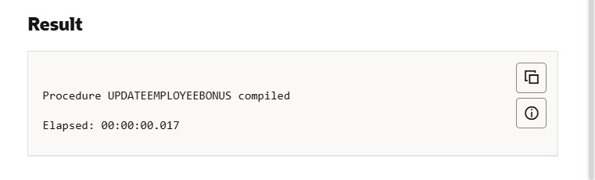

BEGIN

    UpdateEmployeeBonus('IT', 10);

END;

/

SELECT * FROM Employees WHERE Department = 'IT';

**OUTPUT:**

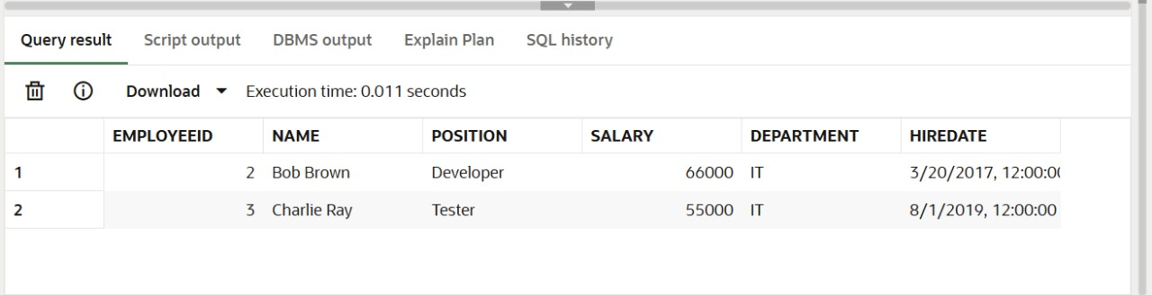

**SCENARIO 3:**

CREATE TABLE Accounts (

    AccountID NUMBER PRIMARY KEY,

    CustomerID NUMBER,

    AccountType VARCHAR2(20),

    Balance NUMBER,

    LastModified DATE,

    FOREIGN KEY (CustomerID) REFERENCES Customers(CustomerID)

);

CREATE OR REPLACE PROCEDURE TransferFunds(

    p_from_account IN NUMBER,

    p_to_account   IN NUMBER,

    p_amount       IN NUMBER

)

IS

    v_from_balance NUMBER;

BEGIN

    IF p_amount <= 0 THEN

        RAISE_APPLICATION_ERROR(-20001, 'Transfer amount must be greater than zero.');

    END IF;

    -- Get current balance of the source account

    SELECT Balance INTO v_from_balance

    FROM Accounts

    WHERE AccountID = p_from_account;

    IF v_from_balance < p_amount THEN

        RAISE_APPLICATION_ERROR(-20002, 'Insufficient balance in the source account.');

    END IF;

    UPDATE Accounts

    SET Balance = Balance - p_amount,

        LastModified = SYSDATE

    WHERE AccountID = p_from_account;

    UPDATE Accounts

    SET Balance = Balance + p_amount,

        LastModified = SYSDATE

    WHERE AccountID = p_to_account;

    DBMS_OUTPUT.PUT_LINE('₹' || p_amount || ' transferred from Account ID ' || p_from_account ||

                         ' to Account ID ' || p_to_account);

EXCEPTION

    WHEN NO_DATA_FOUND THEN

        RAISE_APPLICATION_ERROR(-20003, 'One of the accounts does not exist.');

END;

/

**OUTPUT:**

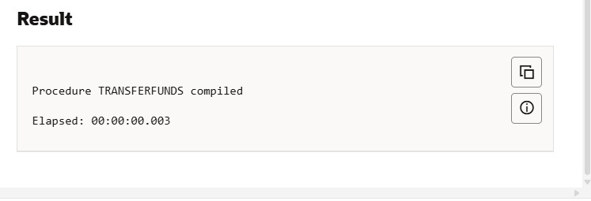

BEGIN

    TransferFunds(101, 102, 3000);  -- Transfer ₹3000 from Account 101 to 102

END;

/

**OUTPUT:**

